# Problem statement

**In the year 2015 to 2017, City Hotel and Resort Hotel have seen high cancellation rates. lowering cancellation rates is both hotels primary goal to increase their efficiency in generating revenue.**

Research question

1. What are the variables that affect hotel reservation cancellations?
2. How can we make hotel reservations cancellations better?
3. How will hotels be assisted in making pricing and promotional decisions?

Hypothesis

1. More cancellations occur when prices are higher.
2. When there is a longer waiting list, customers tend to cancel more frequently.
3. The majority of clients are coming from offline travel agents to make their reservations.

For analyse the data we are using Python

* First, we need to import the library to work and use the directory and function of python
* After Importing required library, we need to import the Raw data sheet in which we have to perform the EDA (Exploratory Data Analysis)
* Now when we have imported the CSV file to our compiler
* It is a hotels data so it must include customers personal data like name and contact number before working on that we have to remove that for privacy of customers.
* We also have to delete agent and company column because of missing data in that column.

Now Let’s see Reservation status count in percentage.

* Booking not cancelled = 63%
* Booking cancelled = 37%

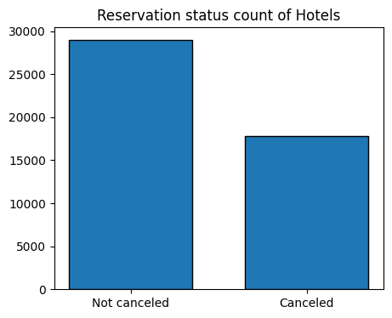

In previous chart we have the overall cancellation percentage now let’s see the percentage with respect of hotels

### **Resort hotel reservation status**

* Not Cancelled: 72%
* Cancelled: 28%

### **City hotel reservation status**

* Not Cancelled: 58%
* Cancelled: 42%

(City hotel has more booking percentage but also have more cancelation percentage)

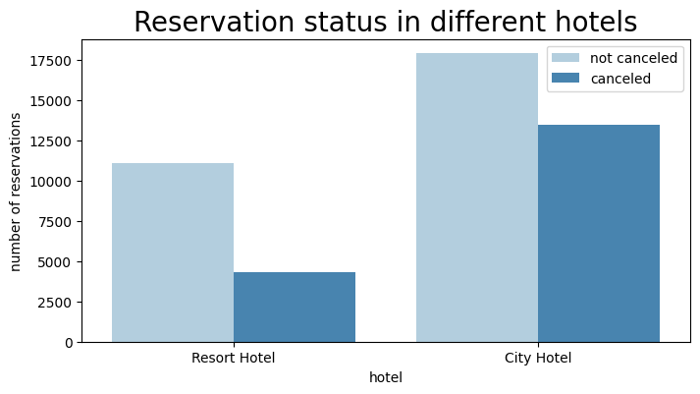

**Visualising Average daily rate (ADR) of city and resort hotels.**

The Average Daily Rate is a key performance indicator that represents the average room rate that a guest pays per room per day.

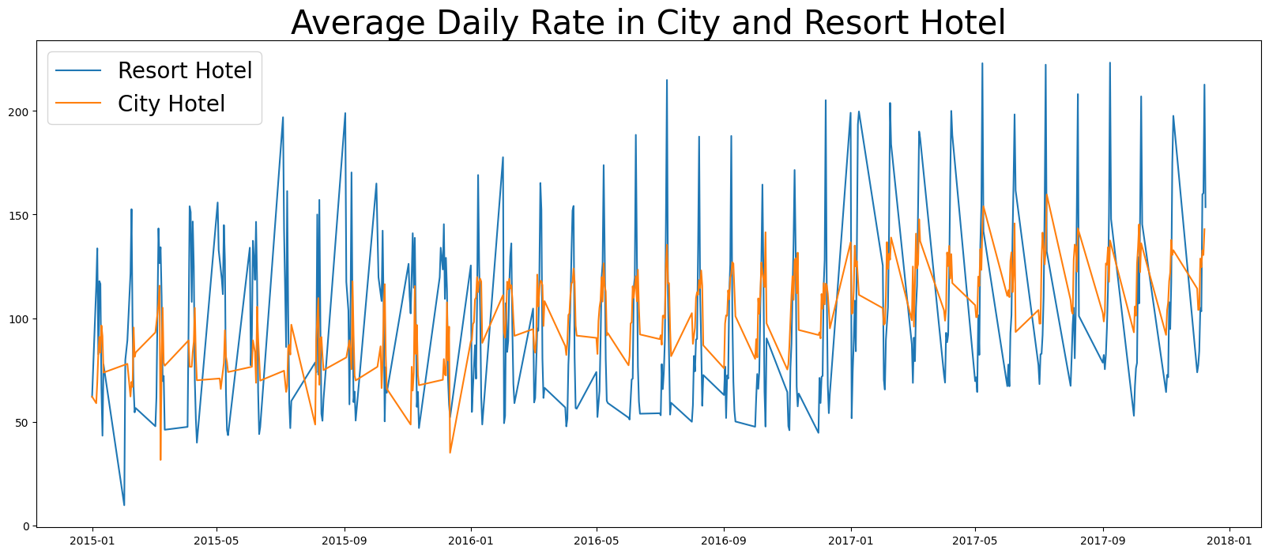

**\*Important\***

* ADR of resort hotel is much higher than City hotel
* High prices might be the reason for cancellation for resort hotel.

Reservation status with respect to months for the hotels.

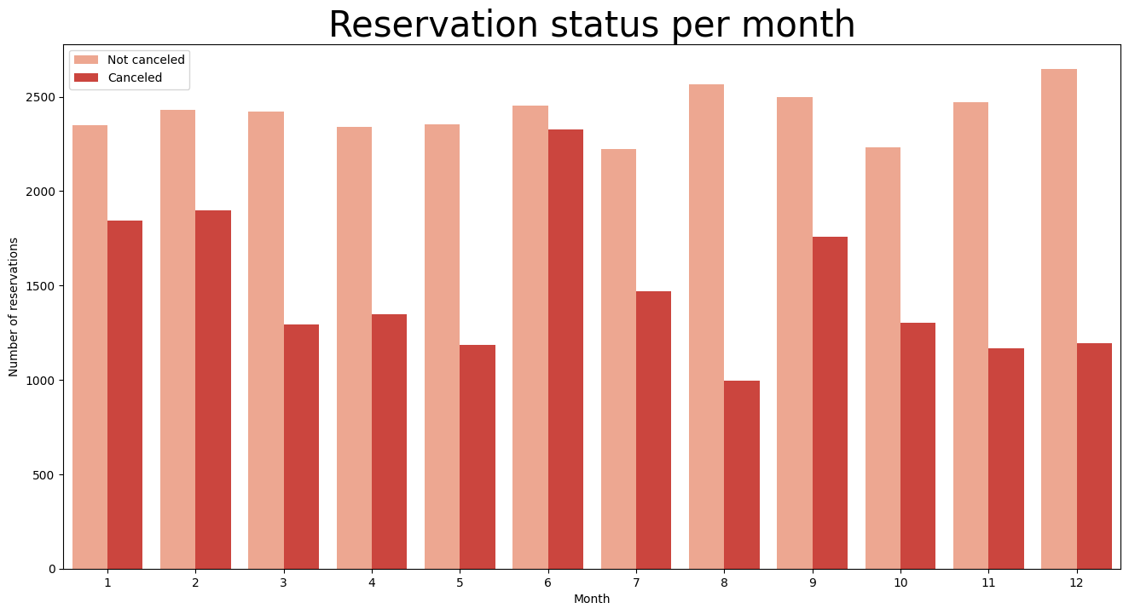

* Highest Cancellations: June
* Lowest Cancellations: August
* Highest Reservation: December
* Lowest Reservation: October

Reservation status with respect to months for different hotels

**Resort Hotel**

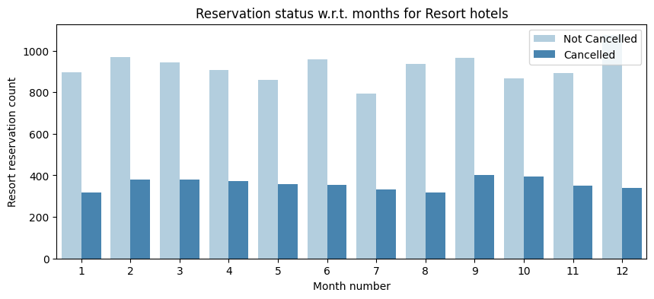

* Highest cancellation: September
* Lowest cancellation: July and January
* Highest Reservation: December
* Lowest Reservation: July

**City Hotel**

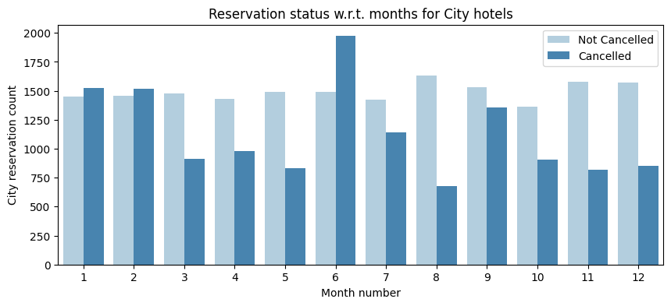

* Highest Cancellation: June
* Lowest Cancellation: August
* Highest Reservation: August
* Lowest Reservation: July

### **ADR by month for cancelled reservations only**

ADR per month for Resort Hotel

1. Highest ADR Resort: September
2. Lowest ADR Resort: January

ADR per month for City Hotel

1. Highest ADR City Hotel: June
2. Lowest ADR City Hotel: August

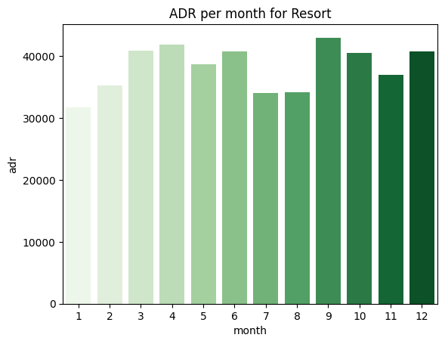

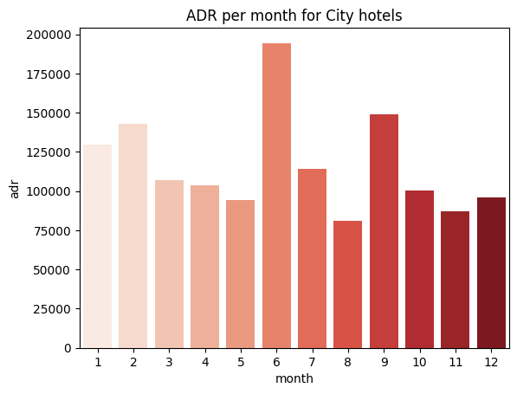

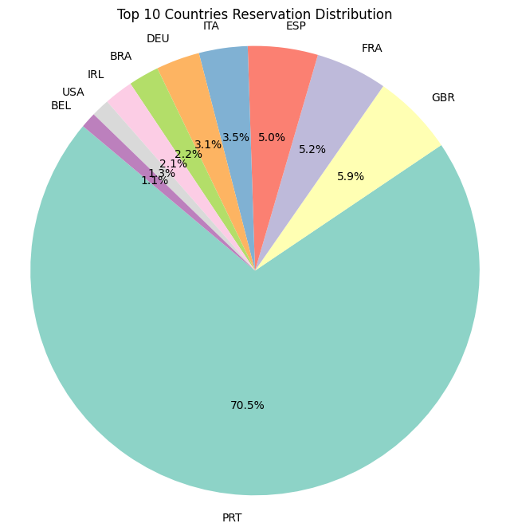**Analysing cancellation by country**



Here we can see by analysing the country Portugal has the highest cancellation rates 70.5%

Suggestion

* Hotel need to try to lower the rates for the specific hotels based on Portugal. They can also provide discounts to that location.
* They can also increase the quality and should take daily feedback more sincerely for their hotels and their service mainly in Portugal to reduce the cancellation rates in Portugal.

**Sources of Booking (Market segment) in Percentage**

Online TA 47%

Offline TA/TO 20%

Groups 16%

Direct 10%

Corporate 04%

Complementary 02%

Aviation 01%

**Now we can see the 47% of bookings are coming from the online source**

1. Now we can assume that the reason of cancellation is product might be different from the shown picture
2. Prices might be high when compared with the other hotels in locality
3. Might be bad social media or google revies about hotels

Suggestions to overcome cancellation

* Provide Accurate photos of hotel to reduce cancellation
* Use more reliable platform that allows guests to make reservation easily
* Stay competitive with the pricing while maintaining the quality and service
* Encourage guests to leave positive feedback on social media or online modes like google
* Use more social media platform to promote hotel

**On the overall factor which hotels need to take action about**

* Cancellation rates goes up as the prices goes up. In order to prevent cancellations hotel could work on their pricing strategies and try to lower the rates for the specific hotels based on locations. They can also provide discounts to the customers.
* As the ratio of the cancellation and not cancellation of the resort hotels is higher than the city hotels. So, the hotels should provide a reasonable discount on the room prices on weekends or on holidays.
* In the month of June hotels can start campaigns or marketing with a reasonable amount to increase their revenue as the cancellation is the highest in this month.
* They can also increase the quality and should take feedback more sincerely of their hotels and their service to know what problem guests are facing and try to improve them.
* Online is the main source of booking because of that hotels need to increase the engagement on online source and also check for the service they are showing to their mode.
* Offer discounts or perks for guests who book in advance, encouraging early reservations.